Physics 1 Unit 1 – 1D Kinematics and Error Analysis Name: ___________________________

IB 1.2 Graphing Uncertainty

Graphing Lab Activity

Warmup

An experiment was done to determine the relationship between the distance a cart moved and the time it took to do this. The data is already graphed below with error bars and a best-fit line.

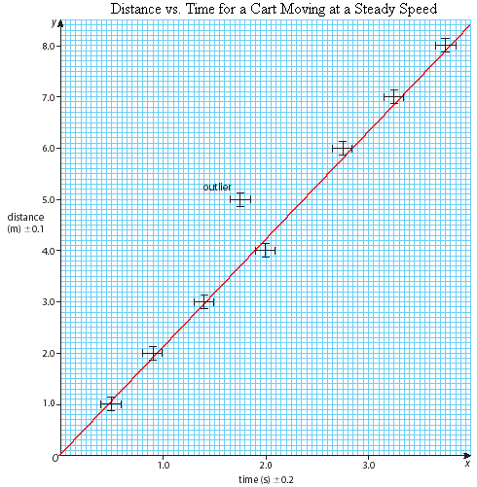

1. Calculate the **slope** of the best-fit line. Show your work, including equation and substitution with units.
2. Write the experimental **linear relationship** for this data. (Substitute specific symbols, the slope and y-intercept with units into the general equation for a line.)
3. Compare your experimental relationship to the math model for this experiment and make a conclusion about the meaning of the slope of the best-fit line.

Use the math model **d = v·t** (distance = velocity x time).

Density Graph Laboratory Data Collection

**Goal:** As a class we will collect data for the mass and volume of 5.0 mL, 15.0 mL, 25.0 mL, 35.0 mL and 45.0 mL of water. This data will be used to create a graph for determining the density of water.

1. Record the mass of the graduated cylinder you will use for this experiment.
2. Using the graduated cylinder, measure each volume of water using the appropriate number of significant digits for your graduated cylinder.
3. Record the mass for each volume of water within the graduated cylinder.
4. Calculate the mass of water for each volume.
5. Share your data with the class.

Mass of empty cylinder: ________________

|  |  |  |  |  |  |
| --- | --- | --- | --- | --- | --- |
| Target Volume | 5.0 mL | 15.0 mL | 25.0 mL | 35.0 mL | 45.0 mL |
| Actual Volume |  |  |  |  |  |
| Mass Cyl + H2O |  |  |  |  |  |

**Class Data: Volume of Water**

|  |  |  |  |  |  |
| --- | --- | --- | --- | --- | --- |
| Target Volume | 5.0 mL | 15.0 mL | 25.0 mL | 35.0 mL | 45.0 mL |
| Your Volume Data |  |  |  |  |  |
|  |  |  |  |  |  |
|  |  |  |  |  |  |
|  |  |  |  |  |  |
|  |  |  |  |  |  |
|  |  |  |  |  |  |
|  |  |  |  |  |  |
|  |  |  |  |  |  |
|  |  |  |  |  |  |
| Average Volumes |  |  |  |  |  |
| STD of Volumes |  |  |  |  |  |

Class Data: **Mass** of Water

|  |  |  |  |  |  |
| --- | --- | --- | --- | --- | --- |
| Target Volume | 5.0 mL | 15.0 mL | 25.0 mL | 35.0 mL | 45.0 mL |
| Your Mass Data |  |  |  |  |  |
|  |  |  |  |  |  |
|  |  |  |  |  |  |
|  |  |  |  |  |  |
|  |  |  |  |  |  |
|  |  |  |  |  |  |
|  |  |  |  |  |  |
|  |  |  |  |  |  |
|  |  |  |  |  |  |
| Average Mass |  |  |  |  |  |
| STD of Mass |  |  |  |  |  |

1. Calculate the average and standard deviation of mass and volume for each of the target volumes. (10 data processing to do. Organize as a class and split this task so that any calculation is done by two people to check accuracy and work together.) Record your results in the tables above. Show your work for the STDs you do here. (or attach)
2. Calculate the average STD for Volume and the average STD for Mass. Record these averages below.
3. Combine all data for your graph below.

Average Data to Graph

|  |  |  |  |  |  |
| --- | --- | --- | --- | --- | --- |
| Target Volume | 5.0 mL | 15.0 mL | 25.0 mL | 35.0 mL | 45.0 mL |
| Average Volume |  |  |  |  |  |
| Average Mass |  |  |  |  |  |

Average STD for Volume: _________ Average STD for Mass: __________

1. Decide how you should create your graph such that the slope of the line graphed will be the density of water. (Each student is required to create their own graph.) Title your graph.
2. Choose a scale for both axes that a) includes 0, b) will use most of the graph space available to display the data, and c) uses the graph paper in convenient units (Each small grid block = .1, .2, 1, 2, 5, 10 etc…) Label your axes with the quantity name, symbol and unit.
3. Graph the Average Data points.
4. Add error bars in each dimension on each point according to the average STD values.
5. Draw your best fit line. (minimize perpendicular distance between each point and the line.)
6. Determine the slope of this best fit line. (Show your work)
7. Determine the equation of this best fit line.

1. Draw a maximum slope line that passes through all error bars.
2. Determine the slope of the maximum line. (Show your work.)
3. Determine the y-intercept of the maximum line.
4. Draw a minimum slope line that passes through all error bars. (Attach your graph)
5. Determine the slope of the minimum line. (Show your work.)
6. Determine the y-intercept of the minimum line.
7. Determine the uncertainty in the slope of the best fit line. (Max slope – min slope)/2
8. Determine the uncertainty in the intercept of the best fit line. (Max int – min int)/2
9. Write the equation of the best fit line with uncertainties for the slope and intercept included, rounding the slope and intercept values to match the uncertainty in each.
10. State your measured density of water. Find your percent error when compared to the expected density of water = 1.00 g/mL.